🧪 🔍 LAB: Mastering grep (Real Practice)
🎯 Goal
To learn how to:
- Search logs
- Filter errors
- Find patterns

⚙️ Step 1: Create a sample log file
nano app.log
Paste this:
INFO: Application started
INFO: User login successful
ERROR: Database connection failed
WARNING: Disk space low
INFO: User logout
ERROR: Timeout occurred
INFO: Backup completed
Save:
- CTRL + O → Enter
- CTRL + X

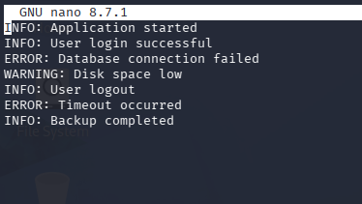
🔍 Step 2: Basic search
grep ERROR app.log
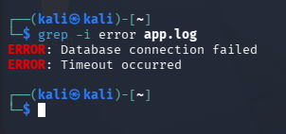
👉 Output:
ERROR: Database connection failed
ERROR: Timeout occurred

🔢 Step 3: Show line numbers
grep -n ERROR app.log
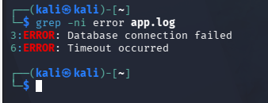

🚫 Step 4: Exclude results
grep -v INFO app.log
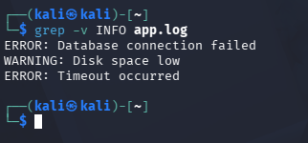
👉 Shows everything except INFO

📊 Step 5: Count matches
grep -c ERROR app.log
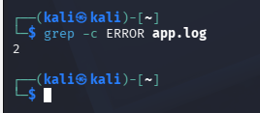

🔥 Step 6: Real-world (SSH logs)
Now use real logs:
journalctl -u ssh | grep Failed
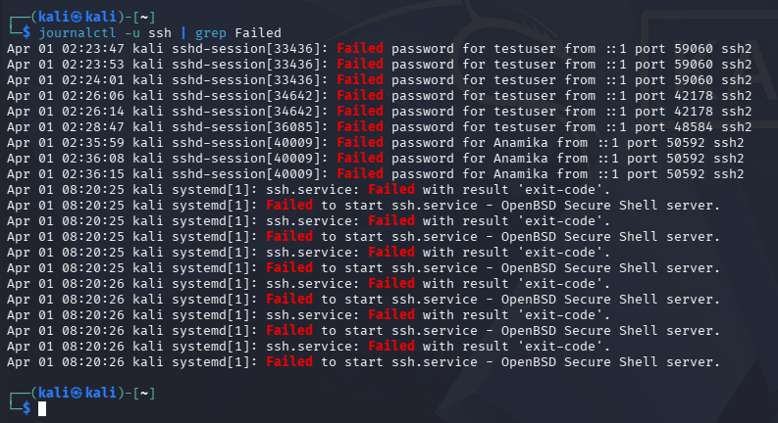
👉 Find failed login attempts

journalctl -u ssh | grep Accepted
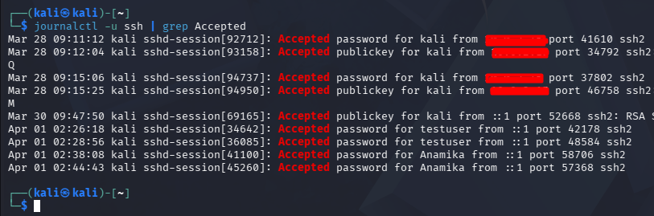
👉 Find successful logins

⚡ Step 8: Combine with other commands
journalctl -u ssh | grep Failed | wc -l
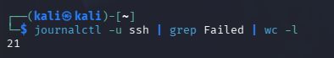
👉 Count failed login attempts 🔥

🎯 Step 9: Search multiple patterns
grep "ERROR\|WARNING" app.log
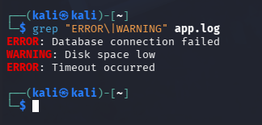
👉 Finds both ERROR and WARNING

💡 Step 10: Highlight matches
grep --color=auto ERROR app.log
👉 Highlights results (very useful)

🧠 What you just learned
You can now:
- Debug logs
- Detect issues
- Filter important data

🎤 Interview-ready answer
Say this:
I use grep to filter logs for errors, failed logins, and specific patterns. I often combine it with journalctl for real-time troubleshooting.

🚀 Mini Challenge (try now)
👉 Find only WARNING:
grep WARNING app.log
👉 Count INFO logs:
grep -c INFO app.log
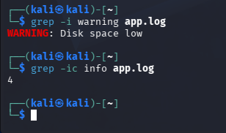

💥 Pro Tip
Most used combo in real jobs:
journalctl -u service_name | grep error

